# Dev Project (you can take 1 week to finish)

We have a web application that allows users to share youtube videos. As a backend developer, you will help build the server-side logic to power the frontend.

Note:

* You should build a simple UI to demonstrate your backend. It does not have to look exactly like the pictures.
* Feel free to add any features that you think are interesting or solutions for different use cases. E.g: system handles a large number of users? You will surely get bonus points for them as well (and maybe a beer).

Once you have completed the application, please deploy it to the cloud, zip the whole folder (please make sure your zip file includes your .git folder for full history) and submit it to:

[Dev-backend-submit](https://forms.gle/ocRXRtNoEKyzieqW6)

**Required Features:**

* **Register**: As a new user, I want to create an account and sign in by entering the **username** and **password** for the first time. (Picture 1)
* **Login**: As a registered user, I want to sign in by entering the username and password. (Picture 1)
* **Share movie**: As a signed in user, I want to share a youtube movie by clicking the “Share a movie” button (Picture 2) and filling the share form (Picture 3).
* **See movie list**: As a visitor, I want to see a list of all shared movies. (Picture 1) (no need to display the number of up/down votes)

**Technical requirements:**

* Use Git and commit often
* Have integration test
* Have unit test

**Picture 1 - Home page**

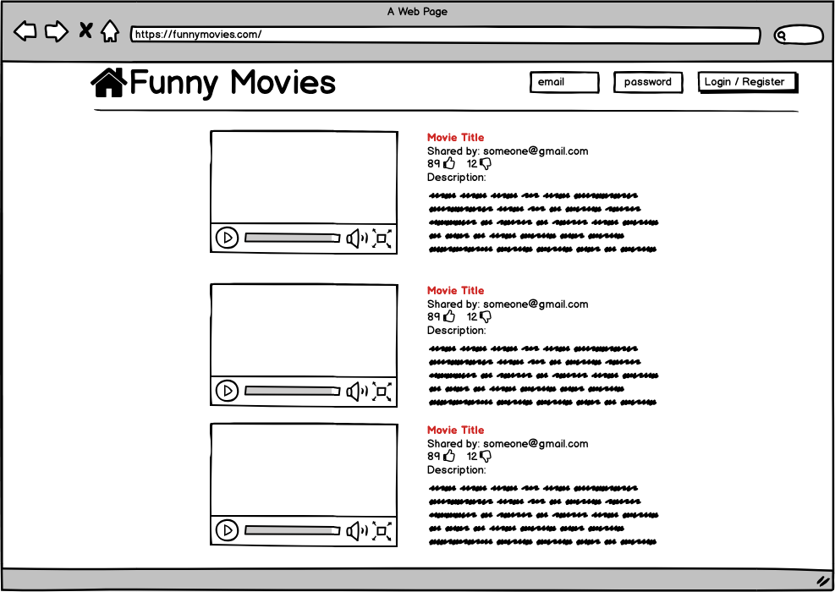

**Picture 2 - Home page signed in**

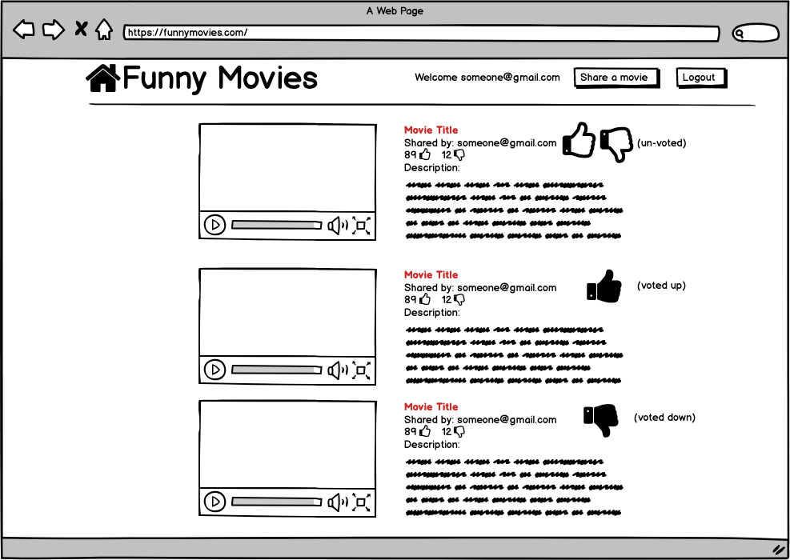

**Picture 3 - Share page**

